**Math 326 – Experimental Design**

**Exam 3 (100 Points)**

**Instructions:**

* Do not look at the exam until you are ready to start.
* **Record your start and stop times on the exam (even if it is multiple times on this page)**. You can take the exam in several sittings.
* You cannot use your class notes, homework solutions, your book, or anything (or anyone) else (so don't take them with you when you take the exam). You can use a formula sheet that you prepare (8.5x11 – both sides). Once you start reading the test, you cannot update your notes. **Upload the notes (or a picture of the notes) to your exam when you submit it. If you did not use notes, please state on the exam “DID NOT USE NOTES.”**
* Please submit all item in I-Learn by the end of December 19th . **This includes the test, notes, graphs, and R output.**
* You will not talk or provide info about the exam to anyone about the contents of the exam (except Brother Palmer).
* For problems #7-8 you will be using R.
* You may use the following: a calculator, your one page of notes, scratch paper, data sets provided for you in I-Learn in Test 3 module.
* By submitting this exam you certify that you have read the instructions above and have obeyed all the rules with exactness (If you need friendly reminders on the importance of obedience and integrity, please refer to 1 Nep. 3:7 and 2 Nep. 9:34 ☺).

I agree to the terms of this test, and I kept them as I took this exam.

Print name: _Matt Hirschi_____

Start Date/Time: ___8:15 pm______ End Date/Time: _____10:00 pm_______

SHOW ALL WORK ON PROBLEMS REQUIRING CALCULATIONS!!

1. (6 pts.) The Food Science department has a machine that can measure the viscosity of starches found in different food products. They want to calibrate the machine so that they can reproduce results obtained at a local food processor. There are 4 inputs to the machine, each with two levels (a high and low setting): stir rate (in revolutions per minute), heat time (in seconds), temperature hold time (in seconds), and cool time (in seconds).

(i) How many observations are needed to run a full factorial design?

16

(ii) How many observations are needed to run a half factorial design?

8

(iii) List the alias structure of the half factorial design if you use a generating relationship of:

*cool time = stir x heat x hold*

Note: Be sure that all main effects and all interactions (2 way, 3way, and 4 way) are included in the alias structure.

Stir = heat * hold * cool time

Heat = hold * stir * cool time

Hold = stir * heat * cool time

2. (2 pts) When random factors are present (these rules still work even when random factors are not present):

(i) How do you determine what factors contribute to the Expected Mean Square (EMS) of a factor?

The EMS for a factor contains a term for the factor itself, plus a term for each Random inside factor.

(ii) What should you use in the denominator to calculate your ANOVA table F statistic?

Find the MS whose expected value has the same terms (except for the factor itself) as the EMS for the factor you want to test

3. An online marketing company runs an experiment involving 3 different website designs (classic, youth, and modern) and two levels of audio status (silent and enhanced). They are interested in the sales associated with each possible online experience and randomly assign each of 12 similar days (all were Tuesdays) to one of the 6 possible treatments. They wish to assess the effects for website design, audio status, and the interaction. At the end of each day, the total sales are recorded. Thus, the experimental design can be illustrated with the following diagram, with “-" denoting an experimental unit to be measured:



The ANOVA decomposition of the total of 12 observations is shown in the diagram below, where “?" denotes a number that is hidden from your view.



In the space below, give numbers for the locations marked (a)-(h) in the diagram. [You do NOT need to fill in every “?”, just enough of the “?” to help you fill in the locations marked (a)-(h).] Excel would be a great tool to use to complete this problem.

(a) (1 pt.)_______26___

(b) (1 pt.) _______-2___

(c) (1 pt.) ______-1____

(d) (1 pt.) ______0____

(e) (2 pts.) ____-2______

(f) (2 pts.) _______2___

(g) (2 pts.) ______2____

(h) (2 pts.) ____1______

**[NOTE: The next 3 problems (problems 4-6) discuss experiments that employ slightly different approaches to the similar experimental questions. You might be wise to skim all 3 scenarios before starting to answer the questions.]**

4. A researcher is interested in the effect of vitamin supplement status (placebo, moderate dose, and heavy dose) and flu shot status (placebo shot and flu shot) on the severity of illness during a 3 month period (Dec 1-Feb 28). The researcher is also interested in the interaction of vitamin supplement status with flu shot status. Forty (40) families (each with 3 children living at home) were recruited for the study. Each of the 40 families was randomly assigned to receive either placebo shots or flu shots. Within each participating family, each child was randomly assigned to one of the 3 possible vitamin supplement levels. A blinded physician monitored the health status of each subject during the study period and assigned each subject's severity-of-illness score at the end of the study.

(a) (2 pts.) What is the response variable?

Severity of Illness during a 3 month period

(b) (2 pts.) What are the experimental factors, and what are the levels of each factor?

Supplement Status - Placebo, Moderate Dose, Heavy Dose

Flu Shot Status- Placebo, Flu Shot

(c) (2 pts.) Label each factor identified in part (b) as fixed or random?

Supplement Status – Random

Flu Shot- Fixed

(d) (2 pts.) Was blocking used in this study? If so, what was the block?

Yes, they did, On family.

(e) (2 pts.) What is the experimental unit for evaluating the effect of flu shot status?

Severity of illness score.

(f) (2 pts.) Which design is used in this study? (Circle one)

i. BF[1]

ii. BF[2]

iii. CB[1]

iv. SP/RM[1;1]

(g) (2 pts.) Write down the statistical model for the observed values, defining all symbols used.

αijk = supplement supplement status

βij = flu shot status

Yij = αijk + βij + αijk * βij + εij

(h) (2 pts.) Using your notation for the model in part (g), write down the null and alternative hypotheses for testing the effect of vitamin supplement status.

Ho: α1 = α2 = α3 = 0

Ha: At least one is different

Ho: β1 = β2= 0

Ha: At least one is different

Ho: There is no interaction

Ha: There is an interaction

(i) (8 pts.) Give a partial ANOVA table below. That is, list all sources and the degrees of freedom (df) for each. (Hint: the first line should be “Mean (benchmark)” and the final line should be “Total”.)

**Source df**

**Grand Mean 1**

**Supplement 2**

**Flu Shot 1**

**Interaction 3**

**Residual 32**

**Total 39**

(j) (2 pts.) What are the degrees of freedom for the F distribution used to test if flu shot status is significant?

1 & 32

5. A researcher is interested in the effect of vitamin supplement status (placebo, moderate dose, and heavy dose). Twenty (20) families (each with 3 children living at home) were recruited for the study. Within each participating family, each child was randomly assigned to one of the 3 possible treatments.

A blinded physician monitored the health status of each subject during the study period and assigned each subject's severity-of-illness score at the end of the study.

(a) (2 pts.) Was blocking used in this study? If so, what was the block?

No

(b) (2 pts.) Which design is used in this study? (Circle one)

i. BF[1]

ii. BF[2]

iii. CB[1]

iv. SP/RM[1;1]

(c) (8 pts.) Give a partial ANOVA table below. That is, list all sources and the degrees of freedom (df) for each. (Hint: the first line should be “Mean (benchmark)” and the final line should be “Total".)

**Source df**

**Grand Mean 1**

**Supplement 2**

**Residual 56**

**Total 59**

(d) (2 pts.) What are the degrees of freedom for the F distribution used to test if vitamin supplement status is significant?

2,56

6. A researcher is interested in the effect of vitamin supplement status (placebo, moderate dose, and heavy dose) and flu shot status (placebo shot and flu shot) on the severity of illness during a 3 month period (Dec 1-Feb 28). The researcher is also interested in the interaction of vitamin supplement status with flu shot status. One hundred twenty (120) children were recruited for the study. Each child was randomly assigned to one of the 6 possible treatments. A blinded physician monitored the health status of each subject during the study period and assigned each subject's severity-of-illness score at the end of the study.

(a) (2 pts.) Was blocking used in this study? If so, what was the block?

No

(b) (2 pts.) Which design is used in this study? (Circle one)

i. BF[1]

ii. BF[2]

iii. CB[1]

iv. SP/RM[1;1]

(c) (8 pts.) Give a partial ANOVA table below. That is, list all sources and the degrees of freedom (df) for each. (Hint: the first line should be “Mean (benchmark)” and the final line should be “Total”.)

**Source df**

Grand Mean 1

Supplement 2

Flu Shot 1

Interaction 4

Residuals 111

Total 119

(d) (2 pts.) Give a 1 sentence interpretation for the interaction effect in this study. (Assume that the interaction is statistically significant.)

We have significant evidence to reject the null hypothesis that there isn’t an interaction between vitamin supplement and flu shot status.

(e) (2 pts.) What are the degrees of freedom for the F distribution used to test if flu shot status is significant?

1,111

**For Problems 7 and 8, Please show the output of your results. You can use R.**

7) An experiment was designed to study the corrosion resistance of steel bars treated at three furnace temperatures, 360◦C, 370◦C, and 380◦C and treated with four coatings, C1, C2, C3, and C4. With all of the combinations of Temperature and Coating, each steel bar is positioned in the furnace and heated. After a period of time, the amount of corrosion is measured from each bar. Also, each temperature setting was repeated twice, so there were two bars for each temperature/coating combination. **Do not forget to check to see if you need to do as.factor.** A further description of the analysis is described below in the following table:



1. (4 points) Get the interaction plots and boxplots and describe what you see with each of them.

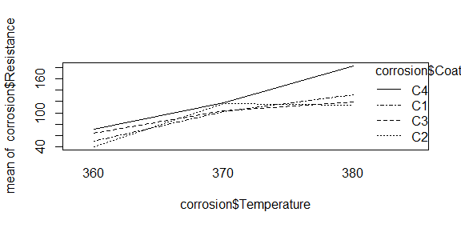

Based on the interaction plot we can assume that there is an interaction between C1, C2, C3.

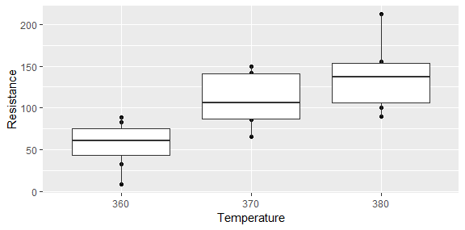

On this boxplot with Temperature we can assume that there is a difference between the temperatures based on the means that it shows.

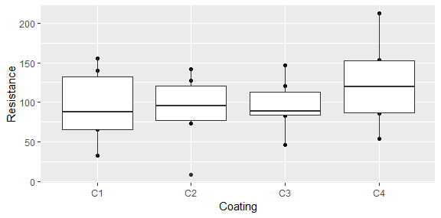

With the coating boxplot we can assume that C4 has a different mean then C1, C2, and C3.

1. (4 points) Check the assumption of equal variance and that residuals are normally distributed and explain your results.

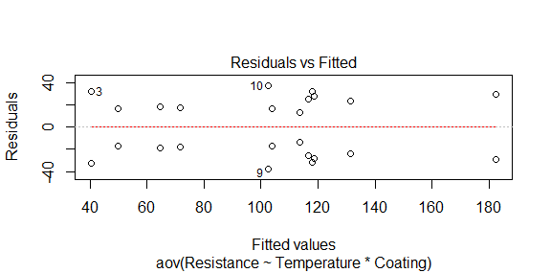

The equal variance doesn’t look very good. Most of the values are right there in the middle and not spread out across all the values. There is a huge gab between 130 and 180 and very few values at the lower values.

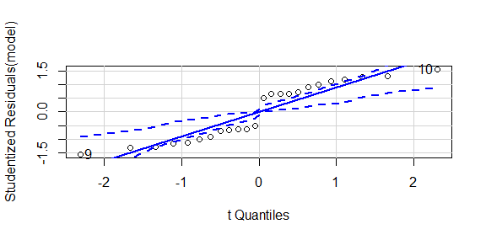

Based on this the normality of the residuals is not normal and we should not move forward with the model.

1. (6 points) For each of the following main effects and interaction: i) state the null and alternative hypotheses, ii) give the test statistic, iii) give the degrees of freedom of the test statistic, iv) state the p-value, v) determine whether you should reject or not reject the null hypothesis, and vi) write a sentence which gives an appropriate conclusion.

Temperature

Ho: µ1=µ2=µ3

Ha: At least one is different

F = 10.226

DF = 2,12

P-Value = 0.00256

We have sufficient evidence to reject the null hypothesis.

Coating

Ho: µ1=µ2=µ3=µ4

Ha: At least one is different.

F = 1.103

DF = 3,12

P-Value = 0.38602

We have insufficient evidence to reject the null hypothesis.

Interaction

Ho: There is no interaction.

Ha: There is an interaction.

F = 0.420

DF = 6,12

P-Value = 0.85180

We have insufficient evidence to reject the null hypothesis.

8) An engineer is interested in the effects of cutting speed (A), tool geometry (B), and cutting angle (C) and their interactions on the life (in hours) of a machine tool. Two levels of each factor are chosen and three replicates for this design are run. Use the data toollife for this problem. **Do not forget to check to see if you need to do as.factor.**

1. (4 points) Check the assumption of equal variance and residuals were normally distributed and explain your results.

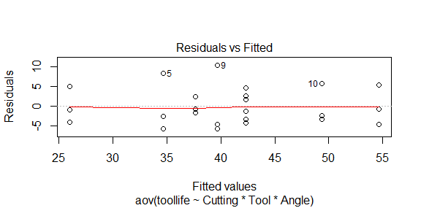

The variance looks pretty good with being equally varied.

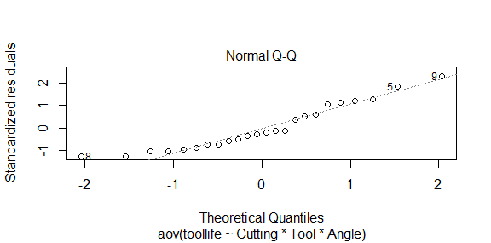

The residuals follow the line pretty well, so we can assume that the residuals are normally distributed.

1. (6 points) Use R to calculate an ANOVA table. For each factor in the ANOVA model, make a statement regarding its statistical significance (cite the correct p-value to support your statement). (Unlike problem #7c, for this problem you do not need to formally state the null and alternative hypotheses, test statistic and degrees of freedom and decision regarding Ho. However, you should write a sentence which gives the appropriate conclusion for each factor, and mention that factor’s p-value.)

Analysis of Variance Table

Response: toollife

Df Sum Sq Mean Sq F value Pr(>F)

Cutting 1 0.67 0.67 0.0221 0.8836803

Tool 1 770.67 770.67 25.5470 0.0001173 ***

Angle 1 280.17 280.17 9.2873 0.0076787 **

Cutting:Tool 1 16.67 16.67 0.5525 0.4680784

Cutting:Angle 1 468.17 468.17 15.5193 0.0011722 **

Tool:Angle 1 48.17 48.17 1.5967 0.2244753

Cutting:Tool:Angle 1 28.17 28.17 0.9337 0.3482825

Residuals 16 482.67 30.17

---

Signif. codes: 0 ‘***’ 0.001 ‘**’ 0.01 ‘*’ 0.05 ‘.’ 0.1 ‘ ’ 1

Cutting has no effect on tool life. P-Value = 0.8836803

Tool has an effect on tool life P-Value = 0.0001173

Angle has an effect on tool life. P-Value = 0.0076787

The interaction of Cutting and Tool has no effect on tool life. P-value = 0.4680784

The interaction of Cutting and Angle has an effect on tool life. P-value = 0.0011722

The interaction of Tool and Angle has no effect on tool life. P-value = 0.2244753

The interaction of Cutting, Tool, and Angle has no effect on tool life. P-value = 0.3482825